Openbox How to Upgrade TP List Via Network

Note:
1, you can upgrade following models via upgrade, upgrade to new firmware or upgrade to new TP list, models including:
--Openbox V8S/ Openbox V8Se/ Openbox V6S/ Openbox V5S;
-- S-V6/ S-V7/ S-V8.
2, Please don’t power off during upgrading! When power off, box will lost data and dead.

1, Upgrade Box with the software which support Network upgrade via USB.

2, After Upgraded , go to “ Network Local Setting” Menu, can find “ Upgrade By Network” Menu, Click “ Upgrade By Network ”, then will enter menu: ( see picture):
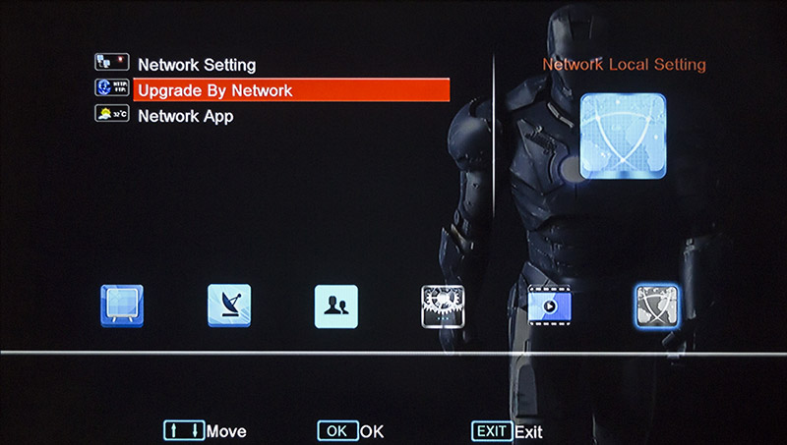
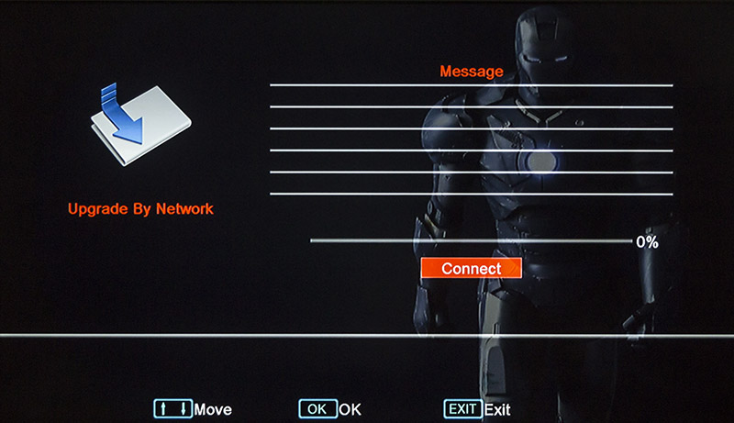
3, click “Connect” , then box will connect to Server , upgrade ready;

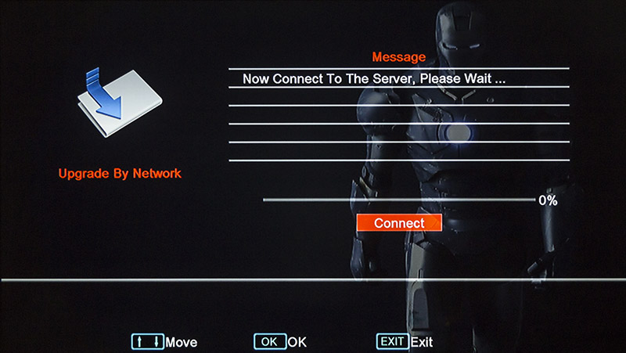

4, You can choose upgrade “ Firmware” or “ TP PROG”, then go to right menu, press OK on remote controller, box will upgrade automatically;

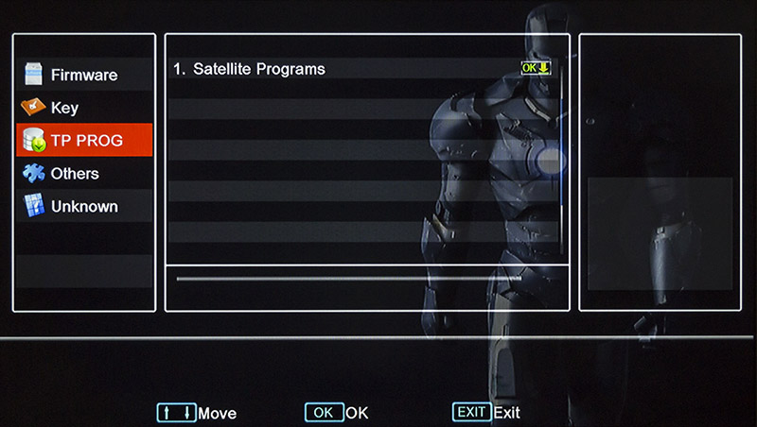

5, After upgraded successfully, box will restar.

